**Lossless Join and Dependency Preserving Decomposition**

Decomposition of a relation is done when a relation in a [relational model](https://www.geeksforgeeks.org/relational-model-in-dbms/) is not inappropriate normal form. Relation R is decomposed into two or more relations if decomposition is [lossless](https://www.geeksforgeeks.org/lossless-decomposition-in-dbms/) join as well as [dependency preserving.](https://www.geeksforgeeks.org/data-base-dependency-preserving-decomposition/)

## ****Lossless Join Decomposition****

If we decompose a relation R into relations R1 and R2,

Decomposition is lossy if R1 ⋈ R2 ⊃ R

Decomposition is lossless if R1 ⋈ R2 = R

**To check for lossless join decomposition using the FD set, the following conditions must hold:**

1. The Union of Attributes of R1 and R2 must be equal to the attribute of R. Each attribute of R must be either in R1 or in R2.

Att(R1) U Att(R2) = Att(R)

 2. The intersection of Attributes of R1 and R2 must not be NULL.

Att(R1) ∩ Att(R2) ≠ Φ

3. The common attribute must be a key for at least one relation (R1 or R2)

Att(R1) ∩ Att(R2) -> Att(R1) or Att(R1) ∩ Att(R2) -> Att(R2)

For Example, A relation R (A, B, C, D) with FD set{A->BC} is decomposed into R1(ABC) and R2(AD) which is a lossless join decomposition as:

1. First condition holds true as Att(R1) U Att(R2) = (ABC) U (AD) = (ABCD) = Att(R).
2. Second condition holds true as Att(R1) ∩ Att(R2) = (ABC) ∩ (AD) ≠ Φ
3. The third condition holds as Att(R1) ∩ Att(R2) = A is a key of R1(ABC) because A->BC is given.

## ****Dependency Preserving Decomposition****

If we decompose a relation R into relations R1 and R2, All dependencies of R either must be a part of R1 or R2 or must be derivable from a combination of [functional dependency](https://www.geeksforgeeks.org/types-of-functional-dependencies-in-dbms/) of R1 and R2. For Example, A relation R (A, B, C, D) with FD set{A->BC} is decomposed into R1(ABC) and R2(AD) which is dependency preserving because FD A->BC is a part of R1(ABC).



**D={AB,BC,CD}**

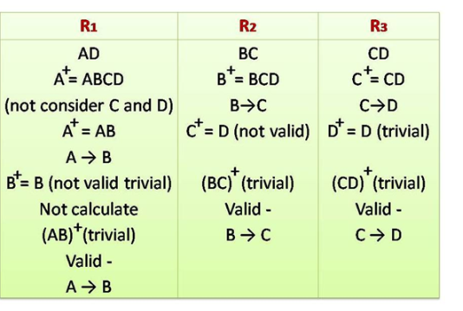

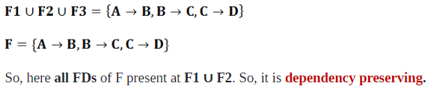

--------------------



**D={AD,BC,CD}**

